

ACCESS FACILITIES – INSIDE THE EVENT


Please note: There are limited hard standing paths in Victoria Park. The stages are all on grass. In the event of bad weather, it is likely that mud and puddles will form.

Ticket Types and Collection

The Accessible Areas are outside with very little shade or protection from rain so please come prepared.

Personal Assistant Pass for Viewing Platform and Ground Level Viewing Area at the Main Stage


PA Passes can be collected from the Access Info Point at the event by showing a ticket and proof of disability. The Access Info Point is located at First Aid & Welfare.

PA passes can be swapped with other members of a group.




Viewing Platform at the Main Stage

The Viewing Platform is designed for wheelchair users and other impairment groups for whom standing is not suitable (subject to availability)



Ground Level Viewing Area at the Main Stage

The Ground Level Viewing is for customers who have access needs but wish to stand, need a less crowded area and/or the option of sitting for short periods of time. (Subject to availability)

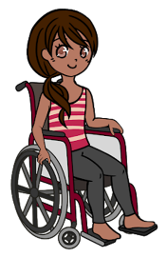

Viewing Platform at the 2nd Stage

An unreserved place on the Viewing Platforms at the
2nd stage and valid with proof of disability.
(Subject to availability)

Blue Badge Parking

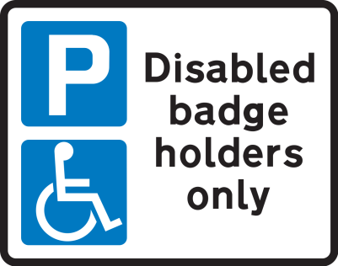
Free of charge and limited to one per paying customer. (Subject to availability). Blue Badge Parking tickets must be booked in advance. You can do this when you buy your event ticket.

Blue Badge Parking tickets are valid with presentation of a blue badge, matching Photo ID and event ticket.

There is no exit from the car park between 8:30pm and 11:45pm.

Facilities

- Entrance


There is a dedicated accessible lane at the main entrance at Crown Gate, on Grove Road.

- Access Manager
You can find the Access Manager at First Aid & Welfare. This will be clearly signposted.


- Accessible Toilets
Accessible toilets are at all toilet blocks, First Aid & Welfare and the Viewing Platforms.

There will be a Changing Places Unit (HDU) situated by the Main Stage Viewing Platform.

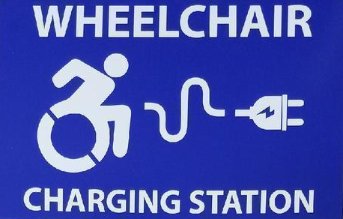
- Charging Points for Power Chairs
These are available at the Main Stage Viewing Platform
and at First Aid & Welfare.

- Lowered Counters
There will be lowered counters where possible at the box office, bars, merchandise stands, and some food outlets. Provisions will be made where they are not available.

- British Sign Language (BSL) Performance Interpreters


BSL Performance Interpreters are available to request for all acts on the Main Stage. Please send requests to access@lidofestival.co.uk


- Hearing (Induction) Loops
These are located at one of the Box Office windows, First Aid & Welfare and limited bars locations.

- Merchandise

Merchandise can be produced in alternative formats within a reasonable time frame. Please email your request to access@lidofestival.co.uk

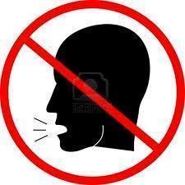
- Quiet space
This is a space that people can use when they need to get away from the crowd for a while. It is located at First Aid & Welfare.

- Hidden Disabilities

If you would like support or advice inside LIDO our Access Manager is based at First Aid & Welfare, near the Main Entrance. Or please contact us in advance with your questions via access@lidofestival.co.uk


- A Dog Spending Area for Assistance Dogs

If you require dog spending area on site, please email your request within a reasonable time frame to access@lidofestival.co.uk

Other Questions Around Accessibility

Please contact us in advance via access@lidofestival.co.uk if you have any other questions which are not answered on the website.

You can also call the Access Information line on 0344 581 0909. Opening hours are Mon - Fri, 9am - 5.30pm.

Medication
Please bring any medication that you would normally take. Medication can be safely stored and refrigerated at the First Aid & Welfare point on site if required.
All medication must be clearly labeled as prescribed and the name on the prescription label must match that of the ticket holder

Please remember that all medication must be self-administered.

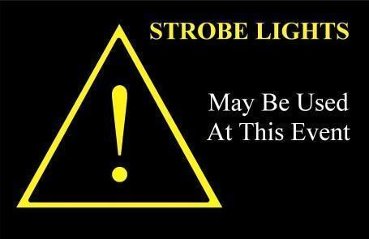
Strobe Lighting & Pyro
Please note that it is likely that most acts performing at the event will use strobe lighting and pyrotechnics as part of their performance.

